**Project Design Phase-II**

**Data Flow Diagram &User Stories**

|  |  |
| --- | --- |
| Date | 03 October 2022 |
| Team ID | PNT2022TMID52777 |
| Project Name | Project – A Gesture Based tool for sterile browsing of radiology images |
| Maximum Marks | 4 Marks |

**Data Flow Diagrams:**

A Data Flow Diagram (DFD) is a traditional visual representation of the information flows within a system. A neat and clear DFD can depict the right amount of the system requirement graphically. It shows how data enters and leaves the system, what changes the information, and where data is stored.

Example: DFD Level 0 (Industry Standard)

**](https://developer.ibm.com/patterns/visualize-unstructured-text/)**

**`**

**DATA FLOW DIAGRAM**

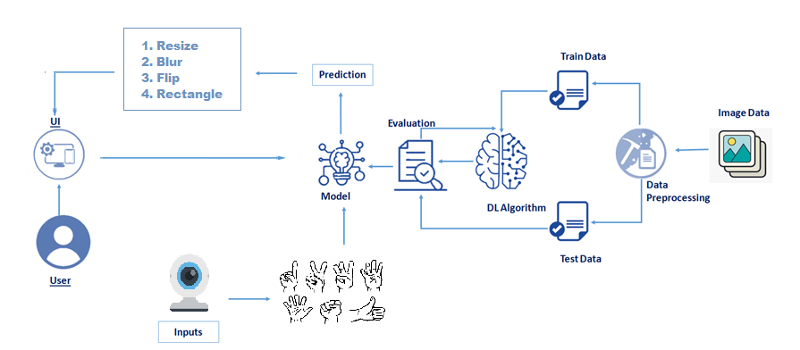

**User Stories**

Use the below template to list all the user stories for the product.

| **User Type** | **Functional Requirement (Epic)** | **User Story Number** | **User Story / Task** | **Acceptance criteria** | **Priority** | **Release** |
| --- | --- | --- | --- | --- | --- | --- |
| Customer (Doctor) | Medical image manipulation | USN-1 | As a user, I can make use of medical image manipulation and providing faster reponses at critical times | I can access the image manipulation data faster as before | High | Sprint-1 |
|  |  | USN-2 | As a user, This model has best ease of use—the system allows me to use just my hands as a natural work tool | I can achieve the set target in short span of time with ease of use | High | Sprint-1 |
| Customer (Surgeon) | Gesture commands operation in real-time | USN-1 | As a user, this prevents my focus shift and change of location while achieving a rapid intuitive reaction and easy interaction. | I can use the browsing of data with sterile postures | High | Sprint-1 |
|  |  | USN-2 | As a user, this model responds to the surgeon's gesture commands in real-time (intuitive and fast) | I can access the manipulated images very fast and intuitive | High | Sprint-1 |